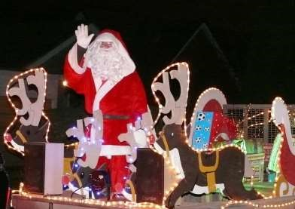

The Newsletter for Middleton on the Wolds

Issue No 11

December 2019

(
Incorporating January
2020)

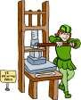
NEXT COPY DATE
14th January

Welcome to this double edition of the Messenger. The reason for combining the 2 months is to avoid problems with producing, printing and delivering the magazines in the busy Christmas period. I have tried to include all of
the services and events for the 2 months so please keep it to hand for the next 9 weeks.

Please send your articles and advertisements for the next Messenger by email at middletonflyer@yahoo.com or, if you are not online, you can pop them through my door. If you don’t get an acknowledgement from me please get in touch.

Wishing you a warm and festive Christmas
& all the best for 2020

Lyn

4 The Paddocks 219500
ADVERTISING COSTS for the Messenger

Rates Month Year

Whole Page £25 £150

1/2 Page £15 £100

1/3 Page £10 £60

Full colour - Print run 500 copies

Contact: Tina 01377 217242, middletonflyer@yahoo.com

editorial
Well, it’s that special time of year again when kids get excited and grown-ups get stressed and all thoughts of sensible behaviour go out the window. But enough about floods, fireworks and pheasants, it’ll soon be Christmas (cheer/groan as you see fit) a time of fun, family and festivities.
There are a few things going on in the village over the
next few weeks which will help bring the village together and which would appreciate our support. You can find details of them in the adverts and announcements in this edition of the Messenger so there is no excuse for missing anything.
Many of you will be looking at the list of events and thinking of going out of a sense of duty. Don’t look at it that way, think of it instead as somewhere to have a bit of fun for yourself; any benefit to the community will just be a (very welcome) by-product. My point is that there is all this stuff going on and it would be a shame to miss out on it.
One other thing I want to flag up is that the Messenger has now been running for one year and it’s time to review how we’re doing. There is no point in having a village newsletter if it doesn’t cover what the community wants so what do you think? Is there anything we should be covering that we aren’t or are we wasting our time in other areas? Please let us know.
Oh, and one last thing. A few people have approached me recently saying things like, ‘Wouldn’t it be a good idea to have something in the Messenger about [insert topic here]?’ To which my reply has been, ‘That would be great. Write something and we’ll print it.’ My point is that we are here to edit and compile the Messenger and to make sure it goes out each month. We’re not here to write it.
Anyway, that’s it for this month so I would like to wish everyone a merry Christmas and a Happy New Year and I’ll see you all in the next issue in February.
Cheers,
Mike

If you have any ideas, comments or complaints (especially complaints) you want to share then send an email to middletonflyer@yahoo.com.
Remember, we can’t respond unless we receive your message.
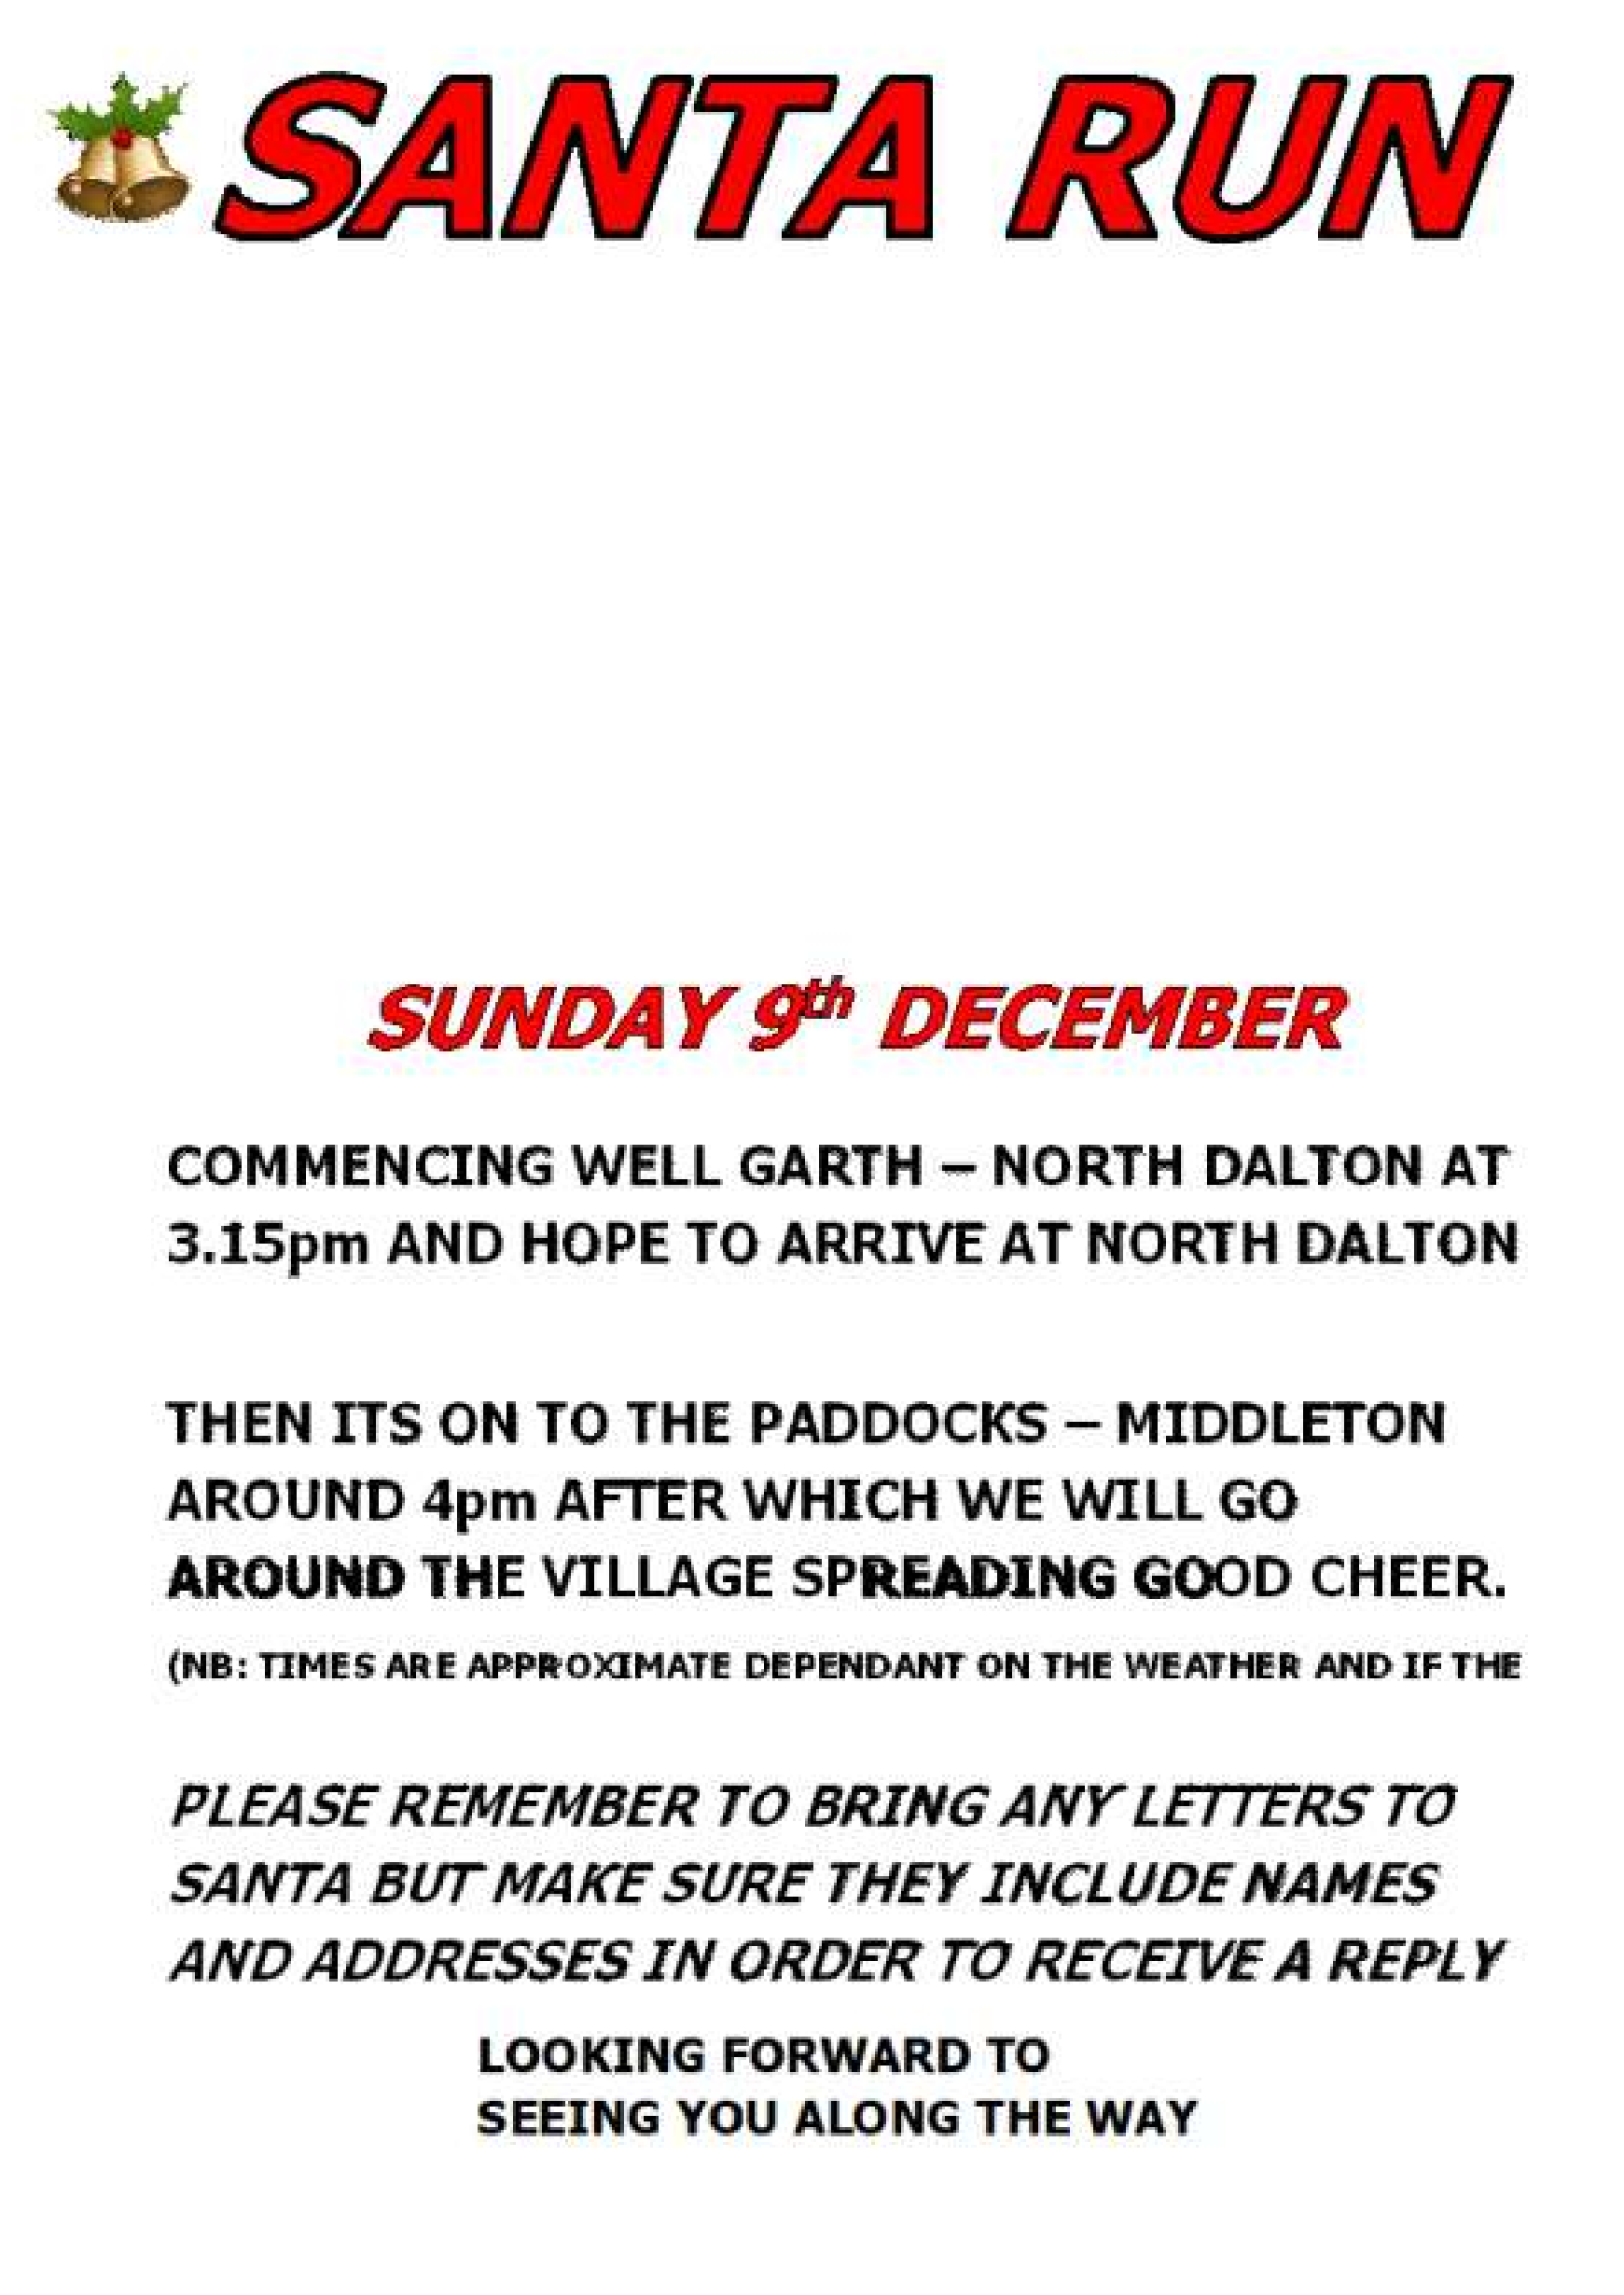
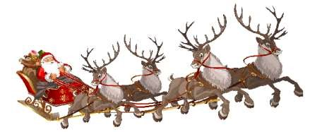

POND APPROX 3.30pm.

(
NB: Times are approximate dependant on the weather and if the
reindeer need a bit of a rest)

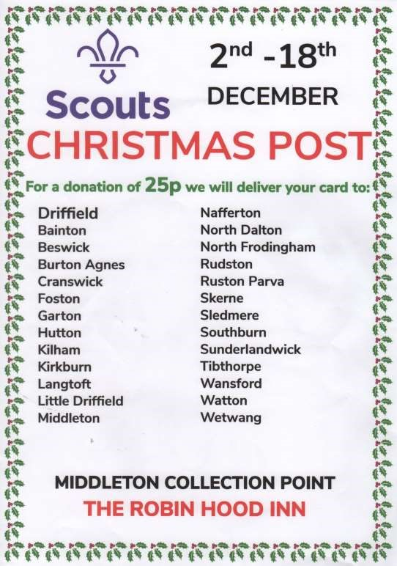

QUIZ PAGE
1 Which programme was transmitted for the last time in 2010 after 37 years What nationality was Christopher Columbus: Italian, Spanish or
2
Portuguese?
3 Which country has more lakes than the rest of the world combined 4 Which politician/rock star used to appear on stage in a coffin?
5 Which Dickens novel features Waxford Squears? 6 In which street is the Bank of England? 7 What was the Iron Lady's maiden name
- Which is England’s largest national park?
- What colour is the car on monopoly's free parking space ?
- In Cockney slang what does Brown Bread mean
Quiz set by Rowland Wooldridge
SUDOKU
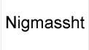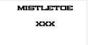 CHRISTMAS DINGBATS

WHERE IN MIDDLETON?

9

4

5

2

6

6

9

1

5

3

2

8

6

6

5

8

3

9

4

8

6

9

1

7

1

3

7

5

8

5

1

6

ABCDEFGHIJKMN
OPQRSTUVWXYZ

Photos by Ian Lavender All answers on page 23

The wolds METHODIST CHURCH bainton

Services for December
Sunday 1st | No morning service
Sunday 1st 3.00pm | Service at the Wolds Methodist Church, Advent
 | Praise led by Rev Robert Amos and Mr Andrew
 | Barraclough
Sunday 8th 10.45am | United service at St Andrews Church Middleton
Sunday 15th 10.30am | Service at the Wolds Methodist Church,
 | Rev Robert Amos, Holy Communion
Sunday 22nd 10.30am | United Carol Service at St Andrews Church,
 | Bainton
Sunday 29th 10.30am | Service at the Wolds Methodist Church,
 | Mrs Liz Ward and Miss Rosemary Newlove

Services for January
Sunday 5th 10.30am | Service at the Wolds Methodist Church,
 | Mr Alan Moir
Sunday 12th 10.30am | United service at the Wolds Methodist Church,
 | Mr Stephen Byass
Sunday 19th 10.30am | Service at the Wolds Methodist Church,
 | Dr Peter Nelson
Sunday 26th 10.30am Service at the Wolds Methodist Church,
Rev Richard Teal
CHARITY COFFEE MORNINGS
will be held in the Reading Rooms on

Saturday 21st December & 18th January

from 10.00am

All are welcome for tea/coffee and teacake
plus a raffle in aid of

Guide Dogs for the Blind (December) & Parkinsons (January)
St Andrew’S church
Services for December
Sunday 1st 10.30am | Holy Communion , Rev’d Cathryn Conner
Sunday 8th 10.45am | Joint Holy Communion, Rev’d Jane Anderson
 | Note time
Sunday 8th 2.00pm | Sykes Masonic Lodge, annual service of lessons
 | & carols. All most welcome to come and sing
 | carols.
Sunday 15th 10.30am | Holy Communion, Rev’ Ruth Canon Kate
 | Goulder
Sunday 22nd 10.30am | Holy Communion, Rev’d Ruth Newton
Tuesday 24th 4.00pm | Christingle service, Rev’d Canon Kate Goulder
Tuesday 24th 10.00pm Midnight in Bethlehem Holy Communion, Rev’d Jane Anderson. Followed by mince pies
& mulled wine.
Sunday 29th 10.00am Benefice HC at Bainton

Services for January
Sunday 5th 10.30am | Holy Communion , Rev’d Cathryn Conner
Sunday 12th 10.30am | Joint worship at Wolds Methodist Church
Sunday 19th 10.30am | Holy Communion, Rev’ Ruth Canon Kate
 | Goulder
Sunday 26th 10.30am | Holy Communion, Rev’d Ruth Newton
Tuesday 28th 10.30am | Coffee Break Praise, Rev’d Jane Anderson

Race Night
A huge and appreciative thank you to the PCC members and friends who worked tirelessly to produce an enjoyable and successful Race Evening on Friday 8th November.
The monies raised for St Andrews Church exceeded £850 and was entirely due to the tremendous support of all the guests who attended this event and the generous donations and sponsorship secured by the PCC members.
Thank you to you all
Betty

A note from your vicar
Christmas - finding God in unexpected places
You probably have your own traditions associated with Christmas, which you hold dear and maybe pass on to others in your family. As children my brother and I would find, in the toe of our Christmas stocking, a raw potato – pushed into it were 1 and 2 pence pieces. If we were
lucky there would also be a 50pence. It looked a bit like a vegetable hedgehog. My mum had one in her stocking as a child, as had grannie. I don’t know why; it is just a tradition in our family – maybe it is a Lancashire thing!
I now have my own tradition. The scene has to be just right. The Christmas tree lights twinkling, a mug of hot chocolate, feet up on the sofa. Then I settle down to watch my favourite Christmas film, ‘The Bishop’s Wife’ starring Cary Grant and David Niven. David Niven plays the Bishop and Cary Grant is an angel who is the answer to the Bishop’s prayer for help.
It is a lovely, gentle film and I never tire of watching it. The Bishop is trying to build a beautiful cathedral to glorify God – or is he?
As the story unfolds, we see how the Bishop has lost sight of the things which really matter – his family and the every day needs of those he serves. He is too tied up with important meetings, business and money to see where he and God are really needed – not stuck up on ‘Sanctuary hill’ distant and removed but among the ordinary, everyday lives we all must lead.
When the Wise Men were looking for the new born king they first went to a palace because that is where they would naturally expect to find him – but, as we all know he was not there. Instead they found who they were searching for among the noise and muck of a cattle stall at the back of an inn.
This Christmas may you be filled with wonder and joy and surprised by God who can be found in the most unlikely of places.
I hope you have a peace filled Christmas.
Rev Jane

Congratulations & thanks
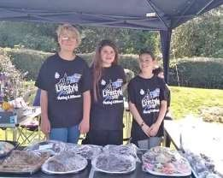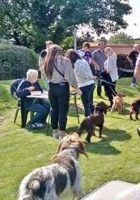

We want to congratulate our daughter, Mikanna Towse and her 2 friends,
Tabitha Simpson and Sophia Neilson as the winning team who took part in
Humberside Police Lifestyle 2019! They've raised £217.11 for Hull Animal
Welfare & have won a day trip to Flamingoland next year!

They have raised the money by doing "doggie fun day" with dogs agility,
best costumes, bake sales, etc.

Thank you to everyone who helped :)

Ann Marie Towse

Thank you from the Keenans

Jennifer and Peter would like to say thank you for all the lovely sentiments expressed in last month's Messenger.

As you can imagine our move has been very hectic but we are slowly getting things sorted out. We have discovered that most of our furniture does not fit into our new lounge. It's a good excuse to recycle and buy new!

We are enjoying exploring our new neighbourhood and being able to walk to the local shops.

Can we again thank friends and neighbours for making our many years in Middleton so enjoyable with special thanks to Betty and Roger.

Local Birds & wildlife
Still very much a time of change as I’m writing this: picture a sunny October autumn scene up at the recreation ground with a contented group of pied wagtails pottering around on the football pitch in the sun (thanks Valerie!) and then we move on to geese flying overhead in large numbers for about a week or more, flying north to feed in the morning and back down south, eventually passing over at dusk as the days grew shorter. And now we are into the occasional overnight frost and lots of rain, and the garden birds are getting enthusiastic about visiting the feeders (and the birdbath doesn’t need refilling at all).
At the end of October the ivy flowered on the embankment, and was covered in hoverflies and flies, and I also saw one extremely tattered comma butterfly resting gratefully on a sunny day. Now it’s November and Hazel has reported a huge flock of starlings perched on wires between Middleton and North Dalton – were they a migration from eastern Europe? – and she also saw fieldfares on Warter Road. She definitely earned the Merlin sighting in her garden!
On 9th November I was entranced by 3 goldcrests in the silver birches just inside the wall round Kipling Court, right next to the pavement. They were hopping around and tweeting very softly to each other as they looked for tiny insects and I stood next to them and watched for quite a while as traffic passed by without either me or the cars disturbing them.
Lastly Wendy has sent some great pictures of fungi she has seen while walking her dogs In our local woods – would anyone like to identify them?
Please send any sightings, comments, observations, mystery objects or general wildlife chat to lavenderbarbara97@gmail.com or text/phone me on 0777 192 7868.
Finally many thanks to everyone who has been in touch through the year – it’s lovely building up a picture of what is going on around the village alongside all us humans! And an extra thanks for the photos and also the comments I have shamelessly lifted and used in the articles!
Have a great Christmas, and let’s see what 2020 has to offer!
Barbara

Messenger correspondence
Hi Mike
Walkway from Orchard Drive to Greenfield Lane
Just an email to try and get an update on the above. It is now some weeks since we were told that the contract to do this had been given, but we are now into November and as yet nothing appears to have happened.
I am extremely disappointed, as we are now into the very season that we need a good safe access past the children’s play ground, that no progress has been made.
I realise that businesses have to plan new jobs into their schedule, but I think this project is now being stretched out in terms of a reasonable time to organise and complete.
I look forward to your response........
Cheers
Steve R Johnson
Orchard Drive Resident.
Hi Steve
Please take a look at the Parish Council page to see how things are progressing. Regards
Mike Kelly
TABLE TENNIS
in the Village Hall on Tuesday evenings
6.00-7.30 pm
Adults £2.00 Children £1.50

All are welcome - any age, any ability
Children under 16 need to be accompanied by an adult
Contact Louise on 217801 for more information

Parish council news
How nice it was to read such a lovely letter to the village hall committee in last month’s newsletter, which was from a village resident saying what a good venue the village hall had been for her birthday party. The committee work hard to maintain the village hall and as the lady said it makes a great venue for parties as well as village group functions / activities. It would be wonderful to see more people use the hall for family parties or people to get involved in organising day / night classes in art, craft, photography etc and for the village to come together more to support such classes / events.
Middleton also has the benefit of another communal building “The Reading Room” which is currently being painted. The building should be considered a valuable asset to the village and it also needs the support of us all. The reading rooms are now being run by a sub-committee under the Parish Council and new committee members are needed, so please contact our parish clerk should you be interested in joining the committee.
I would also like to report how pleased the parish council are to see that the grass verge alongside Beverley Road has been cut. This provides a link back to the village from the public footpath through the woods which ends on Beverley Road. I would like to encourage as many people as possible to walk this path in order that we can demonstrate to EYRC that the walk is much appreciated and therefore they will hopefully maintain the grass verge on a regular basis.
The Parish Council also agreed to accept a quotation for constructing a new path from Orchard Drive to Greenfield Lane; alongside the play area. This has been requested by several residents, and we are pleased that we are now able to fund this path. The works will be carried out as soon as the contractor can programme the works in; subject to suitable weather conditions.
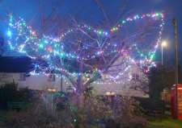
The festive Christmas lights will be going up again this year, decorating the village green which gives the village a warm welcoming feeling for all of us and for those passing through the village. I would like to take the opportunity to wish everyone in Middleton a Merry Christmas and a Happy New Year.
John Eastwood

Middleton book group
Water for Elephants by Sara Gruen
Tells the story of a struggling circus in America during the depression. Jacob, an almost qualified vet has to curtail his studies due to being orphaned. Penniless he jumps a train that is transporting a circus. The novel describes vividly the harshness of life at the time for people and the animals that were their livelihood. The story is related by Jacob in his old age. Some members of the group had seen the film prior to reading the book and considered it to be a somewhat sanitised interpretation.

The Taxidermist’s Daughter by Kate Mosse
A dark gothic mystery set in Victorian times. Describes the revenge taken by a young woman on her abusers. Atmospheric description of the Suffolk coastal area and the art of taxidermy. Mixed response from the group in as much as some thought the book too graphic and others found the build up to the final chapter compelling.

Lindsay

Next books for discussion:
10th December “Union Street” by Pat Barker
“Twelve Days of Christmas” by Trisha Ashley
14th January “The Reluctant Fundamentalist” by Mohsin Hamid
“The Woman in the Window” by A J Finn
 | Contact:  Lyn Dennis | 219500 lyndennis456@gmail.com
VILLAGE LUNCH
THE ROBIN HOOD INN
Monday 13th January
12.15 for 12.30pm
If regulars are unable to attend please contact Lynn Wooldridge on 217457 by Friday 10th January. Anyone wishing to come for the first time is most welcome and should contact Lynn to book a meal.

Middleton on the wolds ce ve school
Executive Headteacher: Mrs E Harros
Station Road, Middleton on the Wolds, Driffield YO25 9UQ
E-mail:middleton.primary@eastriding.gov.uk Tel: 01377 217323
Our next clothing collection will be on Thursday 5th December. Any unwanted clothes, shoes, handbags, hats, scarves, jewellery, belts or cuddly toys can go in the
Clothing Collection

collection. The heavier the collection, the more money that is raised for school, so please save all unwanted items for us. 10p per kilo also goes to The Fire Fighters Charity.

Senior Citizens Tea
Our Senior Citizens Tea will be held on Friday 6th December, 2:003:15pm. All are welcome to come and meet our pupils, be entertained by them with Christmas songs and experience the children serving you with tea and cakes! Carol Service
On Tuesday 10th December at 6.00pm at BAINTON church it is our Christmas Carol service. All are very welcome to attend.

Nativity & Christmas Play
Our Foundation Stage & Key Stage 1 Nativity play will take place at 1:15pm on Wednesday 18th December in the school hall, followed by our KS2 Christmas play which takes place 2:00-3:00pm. Come and be entertained by the children whilst enjoying a mince pie!

Middleton Minis
Our parent, carer, baby and toddler group runs from 1:30 to 3:30pm every Tuesday afternoon (term time only) at Middleton on the Wolds primary school. Drop in for 20 minutes or the full 2 hours. We look forward to seeing you.

On-going Collections
On-going Collections – We collect used stamps, batteries, printer cartridges and mobile phones. Thank you.
We break up for Christmas on Friday 20th December and return to school on Tuesday 7th January.
Thank you for all of the support that we have received throughout 2019.
All staff and pupils at Middleton School wish you all a very Merry Christmas and a Happy New Year.
Middleton on the Wolds Nursery
At Middleton on the Wolds CE (VC) Primary School
Providing education for 2, 3 and 4 year olds Monday - Friday.
→ We accept the Government’s childcare vouchers for up to 30 hours of free provision for 3 year olds (conditions apply)
→ Additional sessions can be purchased for £13.50 per session for 3 year olds and £15.75 for 2 year olds.
→ Lunchtime sessions are £1.75 (free if children attend for the whole day) with the option to purchase a school meal for £2.40.
→ Children are welcome in the term after their 3rd birthday for funded places.
For further details, please contact: Heather Measom or Sharon Stone
Email: middleton.primary@eastriding.gov.uk
Tel: 01377 217323

Village hall news

There is still chance to buy raffle tickets (just £1 each) for the limited edition print donated to us by the artist Robert Fuller or, as a second prize, a large desk diary full of his pictures for us to raffle. You can buy tickets for these from any of the committee members or contact Sharon on 217254 or sroe.general@gmail.com.
The draw will take place at the Christmas Fair on the afternoon of Saturday 30th November.
We look forward to seeing many of you for refreshments and stalls at our Christmas Fair with the usual guest appearance of Father Christmas. He will be switching on the Village Green Christmas lights following the fair.
Don’t forget that you can hire the Village Hall for only £8 per hour or at a reduced rate of £28 for 4 hours and £50 for a day. To enquire please ring me on 219500 or email lyndennis456@gmail.com.

Recipe of the month
Mincemeat and
Cranberry
Puff Swirls

Ingredients to make approx 30 or larger quantity approx 40

· 50g dried cranberries, roughly chopped (plus 2tbsp extra to sprinkle) 80g
· 50g pistachio nuts, finely chopped (plus 2tbsp extra to sprinkle) 80g
· 200g mincemeat 300g
· 1tsp ground cinnamon 1 1/3 tsp
· 2tbsp clear honey 2 ½ tbsp
· plain flour for dusting
· 1 x 375g pack ready-rolled puff pastry 500g
· icing sugar

Each serving contains 153 calories, 12g sugar, 8g fat, 2.5g saturates and 0.2g salt.

Method

Mix the cranberries, pistachio nuts, mincemeat, cinnamon and honey together and set aside. Lightly flour a work surface, then roll the pastry out to a rectangle 33 x 25cm, 13 x 10inch (larger quantity – 43 x 25cm, 17 x 10 inch). Spread the cranberry mixture evenly all over the pastry. Roll up the pastry from the short end into a tight roll (like a Swiss roll).
Place on a non-stick baking sheet and freeze for 12-15 minutes. Preheat the oven to gas 7, 220ºC, fan 200ºC. Remove pastry from the freezer and cut into 1cm (½in) slices.
Arrange on non-stick baking sheets, spaced well apart. Cook on the top shelf for about 15 minutes or until risen and golden brown. Do not over-bake.
Sprinkle over the reserved chopped cranberries and pistachios. Cool and dust with icing sugar. Serve warm or at room temperature.

LOCAL HISTORY
THE READING ROOM

When Colonel Brooksbank provided the village with a Reading Room in 1897 it was a timely acknowledgement of the progress of literacy since compulsory education was introduced in 1880. That is not the whole story of course because Methodism with its
emphasis on the reading of scripture and Friendly Society activity had given certain people of the village a growing confidence with written material.

Nationally business men were keen to exploit the growing market for the printed word by providing the expanded reading public with popular material including puzzles and competitions together with news items written in an entertaining and easily digestible form, in other words the forerunner of today's tabloid press.

On the local scene newspapers such as the Driffield Times and the Beverley Guardian increased their coverage of local happenings and with distribution aided by the railways, it was in fact a golden age for local reporting.

In August 1899 the parish magazine reported "The annual meeting of the Middleton Reading Room was held on Friday June 23rd, Colonel Brooksbank in the chair. After the minutes and balance sheet had been read by the secretary, Mr Phillips, he appointed to serve on the committee the Rev. J. Hare, Messrs H. Simpson, Railton, Towse and George Eastwood; and the members elected Messrs H. Simpson, D. B. Soanes, W. O. Railton and J. Shipley. The Rector then proposed a vote of thanks to Col. Brooksbank for his generous gift of the Reading Room to the parish, and assured him that it was much appreciated by the members, Mr. Eastwood seconded this, and it was carried unanimously. At the first meeting of the new committee it was decided that in future the subscription of members should be as follows:- Yearly members 4/- payable in advance; quarterly members 1/6 a quarter. The committee hope that all members will become yearly members".

At the Village Feast held by the Foresters in that year the Reading Room was included in the toasts which were a feature of those festivities.

On the 30th March 1901 the Driffield Times reported "an addition of 50 volumes has just been made to the library in connection with the Village Reading room at Middleton. Towards the cost of this addition the committee received a donation from Colonel Brooksbank of the Hall". It would be nice to know the titles of some of the books and their subsequent fate.

As a mark of its fame as a village landmark before the First World War a local newspaper had a column by "Paul Pry" entitled "Middleton - Heard at Reading Room Corner" which contained snippets of local information often of a barbed character. In 1913 Kelly's Directory listed Miss Constance Wood as secretary and a report for the Hull Times in 1914 stated that "several newspapers are taken".

The building, which as Waters Appleton recalled to a journalist in 1929, was on the site of 6 thatched cottages and contained a library which was kept under lock and key with books only issued on one day a week. There was also a billiard table, much used by the village doctor, Ernest Clements, an active man who played a big part in village affairs. Membership was strictly confined to males who could as Jack Bentley recalled join at the age of 16 but were expected to remain silent when games were being played.

During the Second World War it was a popular venue particularly for card games but for some years its fortunes went into decline. It was reported in the Parish Magazine in 1960 that the Rector, the Rev E. Winter, had made a number of unsuccessful attempts to revive its fortunes and that year a Reading Room and Youth Group committee were formed.

Over the years the building had deteriorated and in 2006 Madelaine Dewar and Janet James worked hard to secure grants to enable refurbishment of both the Reading Room and Village Hall. The Reading Room remains a useful venue for smaller activities such as Parish Council meetings, coffee mornings, interest groups and of course, elections.

Geoff Wisher

CHARITY COFFEE MORNING

will be held in the Reading Rooms on

Saturday 18th January

from 10.00am

All are welcome for tea/coffee and teacake

plus a raffle in aid of

Parkinsons

LOCAL CONTACTS
Bell Ringing Chris Atkin 217285 Book Group/Middleton Movers Lyn Dennis 219500 Bowls Club Rob Bradley 217435
Country Women’s Association Christine Johnson 217374 First Responders Chris Brent 219469 Line Dancing Pat Pottage 217516 Methodist Chapel Miss P Hodgson 217426
Middleton Messenger Mike Kelly 07713 620912
Lyn Dennis 219500
Middleton Womblers Andrew Naylor 219072
Parish Clerk Sandra Morrison 01262 470496 Reading Rooms Kath Bentley 217456
Recreation Club Dave Newlove 07901 833784
St Andrew’s Church Rev Jane Anderson219471
St Andrew’s Church Warden Roger Lowe 217656 Table Tennis Louise Newlove 217801 Village Hall Lyn Dennis 219500
Village History Geoff Wisher 217517

NEWS FROM OUTSIDE MIDDLETON
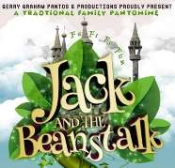
Gerry Graham Touring Pantomime

Jack and the Beanstalk
Lund Village Hall
Friday 13th December Doors open 19.00
£11 adults, £7 under 12’s (Special family tickets available- 1 adult + 1 child£16; 2adults 2 children £32)
Bar, ices, teas, coffees, cakes
Call 01377 217776/219598 or from Beverley Tourist Info.
These touring pantomimes have their scripts updated each year making them topical, relevant & funny, All of these pantomimes feature a great musical score using current chart hits and custom songs written especially for our pantomimes.
A great (oh yes it is!) hilarious, panto for all the family with the famous Jack and the Bean stalk storyline. A six - actor professional performance with full scene changes
What a great way for all the family to start the exciting build up to Christmas. Don’t miss this, come and hiss and boo at the villains and help the good guys with a cheer or two! A sing along and laughter guaranteed!
4 6 3 1 2 8 5 9 7  8 9 2 5 4 7 6 3 1  7 5 1 9 3 6 2 4 8  1 4 9 2 7 3 8 5 6  2 8 6 4 9 5 1 7 3  5 3 7 6 8 1 4 2 9  3 2 5 8 1 9 7 6 4  9 1 4 7 6 2 3 8 5  6 7 8 3 5 4 9 1 2 | Quiz answers  Where in Middleton:  Wolds Waves Hair  Salon  Play area  -  new  equipment  Dingbats:  Festive Season  Frankinsense  Midnight Mass  Snowball  Noel  Kiss under the  mistletoe  1  Last of the Summer Wine  2  Italian  3  Canada  4  Screaming Lord Sutch  5  Nicholas Nickleby  6  Threadneedle Street  7  Margaret Roberts  8  The Lake District.  9  Red  10  Dead

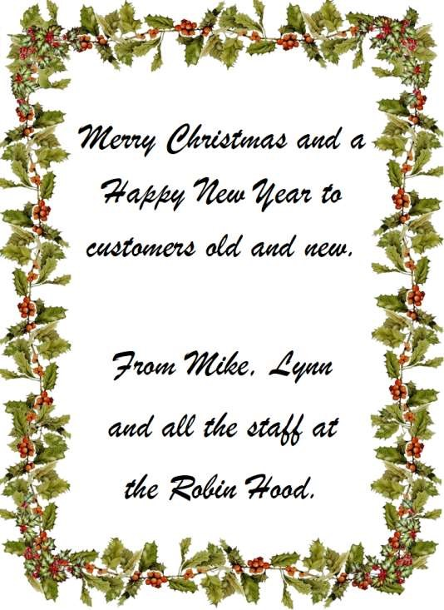
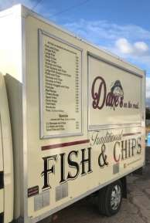

—
Traditional
—

Fish

&

chips

All fish is Haddock skinned and boned

Fish & Chips

5.60

Single Fish

3.90

Large Fish

5.10

Small Chips

1.70

Large Chips

2.80

Fish Goujons & Chips

4.40

Large Fish Goujons & Chips

5.60

Pattie and Chips

2.60

Sausage & Chips

2.60

Sausage or Pattie

0.90

Chicken Nuggets & Chips

3.50

Fishcake

1.10

Beef Burger

2.00

Cheese Burger

2.50

Spam Fritter

1.20

Onion Rings

1.80

Fish Pattie

1.70

Breadcake

0.40

Peas, Curry or Gravy

0.80

Specials

served with Peas, Curry or Gravy

2
x Sausage & Chips

4.00

2
x Pattie & Chips

4.00

Small Fish and Chips

4.60

Layby near to the Roundabout

Every Wednesday

to 7.00pm
4.30

Advertisement
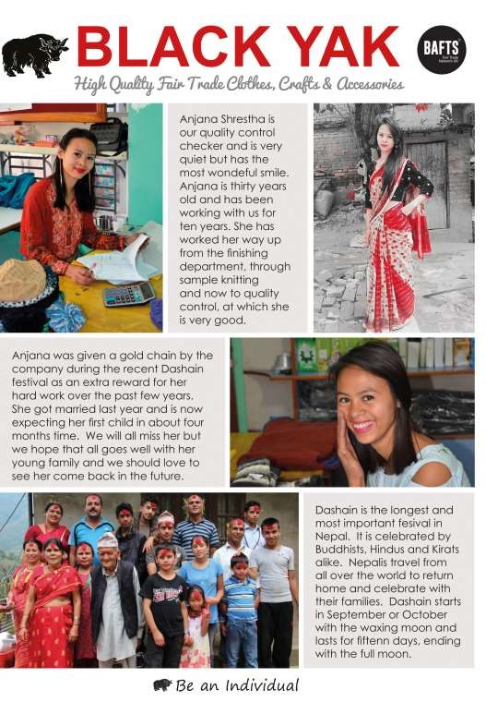

Regular group activities

Weekly Groups
Monday Coffee Morning 10.00am Reading Rooms
(Except when there is a Village Lunch - see below)
Monday Pilates 6.00-7.00pm Village Hall Tuesday Table Tennis 6.00-7.30pm Village Hall
Wednesday Line Dancing 7.30-9.00pm Village Hall Thursday Middleton Movers 2.00-3.30pm Village Hall Thursday Pilates 7.00-8.00pm Village Hall

December
2 Village Lunch 12.15pm Robin Hood Inn
2 Parish Council 7.00pm Reading Rooms
- Middleton Womblers 10.00am Lime View
- Country Women’s 6.30pm Robin Hood
- Book Group 2.00pm Village Farm

- Village Hall Committee 7.30pm Village Hall
- Bell Ringing 7.30pm St Andrew’s Church
21 Charity Coffee Morning 10.00am Reading Rooms

January
6 Parish Council 7.00pm Reading Rooms
8 Bell Ringing 7.30pm St Andrew’s Church
- Middleton Womblers 10.00am Lime View
- Village Lunch 12.15pm Robin Hood Inn
- Book Group 2.00pm Station Road
14 Village Hall Committee 7.30pm Village Hall
16 Country Women’s 7.30pm Reading Rooms
18 Charity Coffee Morning 10.00am Reading Rooms
22 Bell Ringing 7.30pm St Andrew’s Church

LOCAL CONTACTS
See page 22 for details

